PENN SCALE

CM-101 Price Computing Scale
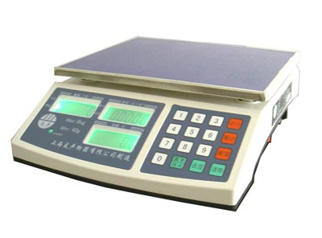

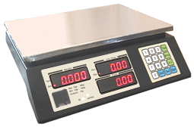


Legal for Trade
Certificate #04-101A1

Specification

Model | CM - 101
Capacity | 30.00 x 0.01 lb / 15.000 x 0.005 kg
Display | LCD ( 5 / 5 / 6 )
Op. Temp. | 0 C ~ 35 C / 32 F ~ 95 F
Dimension
Platter | 300 x 250 mm / 11.8 x 9.8 “
Height | 110 mm / 4.3 “
Length | 335 mm / 13.1 “
Width | 320 mm / 12.5 “
Power
DC | 4 V / 4 Ah Rechargeable Battery
AC | 120 V 50 / 60 Hz
Connecter | Standard AC power connecter
Charge Life | 120 hrs

Calibration Procedure
( Authorized License Dealer only )

Step 1. Turn the scale Power ON

Step 2. While the scale is in Testing Mode,
press TARE key

Step 3. Enter PASS-WORD

Step 4. When the scale displays
“ c a l , f 1 “, press TARE key

Step 5. When the scale displays “ Uload”,
press TARE key with nothing on
the platter,

Step 6. When the scale displays “ load “ ,
place 30 lb weight on the Platter,
then press TARE
the scale will display “span pass”

< Note >
This procedure must be performed ONLY by the
authorized licensed personnel
If done by other, the field inspector from W & M
may NULLIFY the validity of the scale

Method to check the voltage condition

Method 1:
After the self-checking when you switch on the scale, the price window will display: DC *.** (the voltage now)

Method 2:
During the process of usage, you can press the * key and 00 key meanwhile, then the price window will display: DC *.** (the voltage now),then you can press any key to be back to the normal weighing condition.

Penn Scale Mfg. Co., Inc.
150 W. Berks Street
Philadelphia, PA 19122
Phone: (215) 739-9644
Fax: (215) 739-9640

